**Ideation Phase**

**Define the Problem Statements**

|  |  |
| --- | --- |
| Date | 26 May 2025 |
| Team ID | LTVIP2025TMID38618 |
| Project Name | Revolutionizing Liver Care : Predicting Liver Cirrhosis using Advanced Machine Learning Techniques |
| Maximum Marks | 2 Marks |

**Customer Problem Statement Template:**

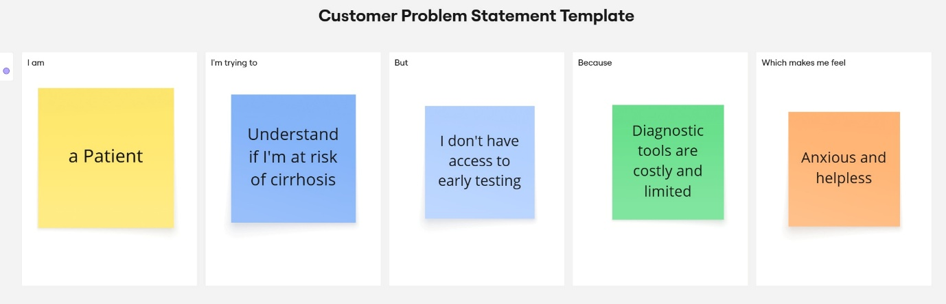

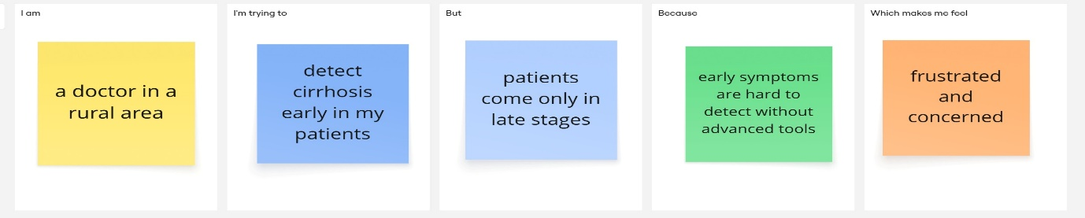

|  |  |  |  |  |  |
| --- | --- | --- | --- | --- | --- |
| **Problem Statement (PS)** | **I am (Customer)** | **I’m trying to** | **But** | **Because** | **Which makes me feel** |
| PS-1 | a Patient | Understand if I'm at risk of cirrhosis | I don't have access to early testing | Diagnostic tools are costly and limited | Anxious and helpless |
| PS-2 | a doctor in a rural area | detect cirrhosis early in my patients | patients come only in late stages | early symptoms are hard to detect without advanced tools | frustrated and concerned |